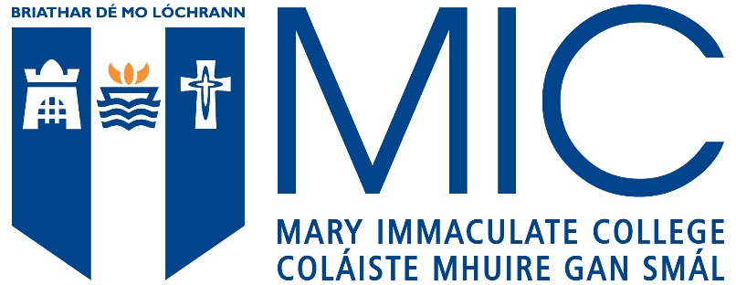
APPLICATION FOR RE-ADMISSION – Year 1

This form is for students who registered on a programme at either MIC or UL, but exited prior to taking examinations.
Students who have taken examinations and wish to apply for internal transfer to MIC, should contact Student Academic Administration for consideration through Student Status Committee.

PART 1 (to be completed by Student)

Name__________________________ Former ID no._____________________

Address___________________________________________________________________

_________________________________________________________________________

PPS Number______________________ ___ Telephone No.______________________

Have you applied through CAO as HEAR or DARE student previously___________
If answer is Yes please state year ____________________________________

Former Course of Study ________________ Cumulative QCA
at time of leaving:__________________

Term and Year Study Term and Year Study
Commenced at the College_______________ was terminated at
the College ________________________

Reason for Terminating_______________________________________________________

__________________________________________________________________________

__________________________________________________________________________

Details of employment or other activity since terminating study at the College. Please supply employer reference(s) where relevant and /or supporting documentation where possible:
__________________________________________________________________________

__________________________________________________________________________

I wish to be readmitted to the College in Semester_______ Academic Year 20__________

To the following Course of Study

1.____________________________________
2.___________________________________
Statement in Support of Readmission (The Student Counsellor or your former Adviser may be able to assist you)
__________________________________________________________________________

__________________________________________________________________________

Student Signature____________________________ Date_______________________

Please email completed application form to:
admissions@mic.ul.ie

CLOSING DATE: 1 JULY
_________________________________________________________________________

FOR OFFICE USE ONLY

Admissions Committee Recommendations/Comments:

Please tick

Satisfies Minimum & Specific  Subject Requirements | Points Score | Accept
Yes  No | Points:___________  Satisfies Minimum Points  Yes  No | Yes  No

Comments:

__________________________________________________________________________
__________________________________________________________________________
__________________________________________________________________________

Signature______________________________ Date_______________________________

